14.43: a)
b) The fractional change in volume is the negative of the fractional change in density.
The density at that depth is then

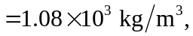
A fractional increase of 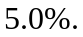 Note that to three figures, the gauge pressure and absolute pressure are the same.

